EX 10 IMAGE GENERATION USING GENERATIVE ADVERSARIAL
DATE:
Problem Statement:
Train a Generative Adversarial Network (GAN) to generate new images from a dataset. Evaluate the quality of generated images using both visual inspection and a quantitative metric such as Inception Score (IS) or Fréchet Inception Distance (FID).
Suggested Dataset: LSUN Dataset
Objectives:
- Understand the architecture of GANs and their adversarial training process.
- Use StyleGAN2-ADA, a state-of-the-art GAN, for high-quality image generation.
- Evaluate generated images using IS and FID metrics.
- Compare generated outputs with real samples and assess realism.
Scope:
GANs are powerful generative models used in image synthesis, super-resolution, style transfer, and more. This experiment familiarizes students with modern GAN architectures and helps develop understanding in both visual and metric-based evaluation of generative quality.
Tools and Libraries Used:
- Python 3.x
- PyTorch
- torchvision
- StyleGAN2-ADA
- torchmetrics
- FID & Inception Score libraries
- CelebA Dataset

Implementation Steps:
Step 1: Clone StyleGAN2-ADA Repository

REPO = 'stylegan2-ada-pytorch'
REPO_URL = 'https://github.com/NVlabs/stylegan2-ada-pytorch.git'

def clone_repo(): if not os.path.exists(REPO): subprocess.run(['git', 'clone', REPO_URL]) sys.path.append(os.path.abspath(REPO))

Step 2: Download Pretrained Generator

MODEL_URL = 'https://nvlabs-fi-cdn.nvidia.com/stylegan2-adapytorch/pretrained/ffhq.pkl'
MODEL_PATH = 'ffhq.pkl'

def download_model(): if not os.path.exists(MODEL_PATH):
import urllib.request
urllib.request.urlretrieve(MODEL_URL, MODEL_PATH)

Step 3: Generate Synthetic Images

def generate_images():
import legacy import dnnlib
G = legacy.load_network_pkl(open(MODEL_PATH, 'rb'))['G_ema'].to(device) os.makedirs('generated_images', exist_ok=True) imgs = []
for i in range(1): # NUM_IMAGES = 1 z = torch.randn([1, G.z_dim], device=device) label = torch.zeros([1, G.c_dim], device=device)
img = (G(z, label, truncation_psi=0.5, noise_mode='const') + 1) * 0.5 save_image(img, f'generated_images/fake_{i}.png') imgs.append(img.cpu()) return torch.cat(imgs)

Step 4: Calculate Inception Score

from torchmetrics.image.inception import InceptionScore

def calculate_inception_score(imgs): loader = DataLoader(TensorDataset((imgs * 255).clamp(0, 255).to(torch.uint8)), batch_size=32) is_metric = InceptionScore() for batch in loader: is_metric.update(batch[0]) mean, std = is_metric.compute()
print(f"Inception Score: {mean:.2f} ± {std:.2f}")

Step 5: Prepare Real Images from CelebA

def prepare_real_images():
dataset = dsets.CelebA(root='./data', split='train',
transform=transforms.Compose([ transforms.Resize(512), transforms.CenterCrop(512), transforms.ToTensor()
]),
download=True)
loader = DataLoader(dataset, batch_size=1, shuffle=True) os.makedirs('real_images', exist_ok=True) for i, (img, _) in enumerate(loader):
if i >= 1: break
save_image(img, f"real_images/real_{i}.png")

Step 6: Compute FID Between Real and Generated Images

def calculate_fid():
subprocess.run(["python", "-m", "pytorch_fid", "real_images", "generated_images"])

Step 7: Run Entire Workflow

def main():
clone_repo() download_model() imgs = generate_images() calculate_inception_score(imgs) prepare_real_images()
calculate_fid()

if __name__ == "__main__":
main()

OUTPUT:
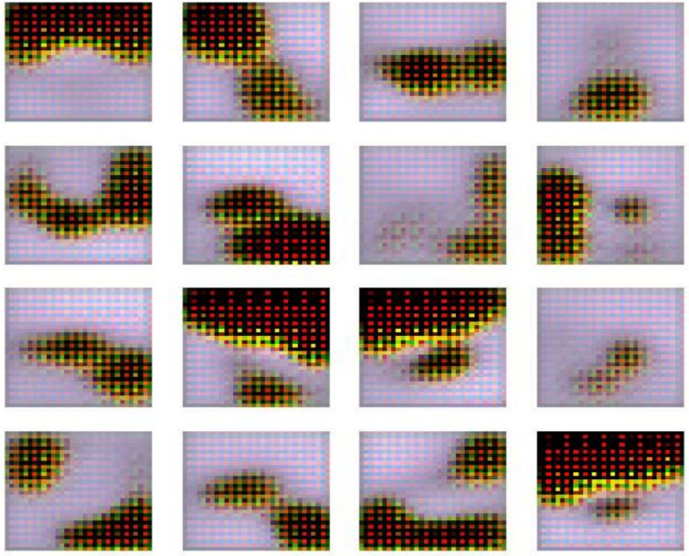

Conclusion:
This experiment highlights the capabilities of advanced GANs like StyleGAN2 in generating photorealistic images. The use of Inception Score and FID provides quantitative support to visual assessments. GANs remain a cornerstone in generative deep learning research, with wide applications in media, design, and beyond.

